Big Data Lab -24/05/2022
Praneeth M V
1NT19IS112
LAB-05

Tasks To complete
1. Create a directory named by your name
>hadoop fs -mkdir /praneeth
>hadoop fs -ls /
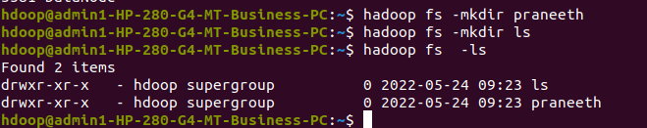
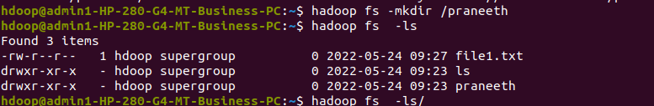
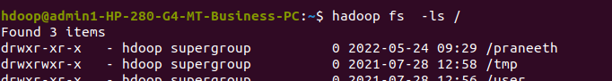

2. Add two empty files into it
hadoop fs -touchz /praneeth/file.txt
hadoop fs -touchz /praneeth/file1.txt

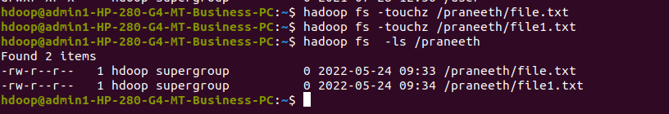
3. List all the files in the directory that you have created

hadoop fs -touchz /praneeth/file.txt
hadoop fs -touchz /praneeth/file1.txt
>hadoop fs -ls /praneeth

4 Create one more directory by your usn and put that inside the directory of your name

>hadoop fs -mkdir /praneeth/1nt19is112
>hadoop fs -ls /praneeth
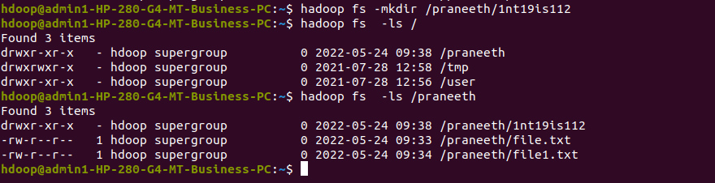

5. Create a file in your local system by the name_usn.txt and add the contents as
"Syntax to list Is command is hadoop fs -Is "

cat > praneeth_1nt19is112.txt
cat praneeth_1nt19is112.txt

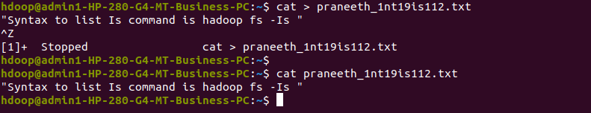

►Put the file usn_name.txt in your hdfs directory called usn
Put empty file of hdfs into the local file system

hadoop fs -touchz /praneeth/1nt19is112_praneeth.txt
hadoop fs -ls /praneeth
hadoop fs -copyToLocal /praneeth/1nt19is112_praneeth.txt
ls
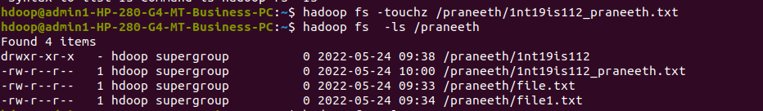
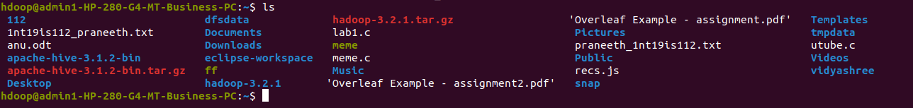

►Use my command to move files from local file system and hdfs file system
hadoop fs -moveFromLocal movefile.txt /praneeth
hadoop fs -ls /praneeth
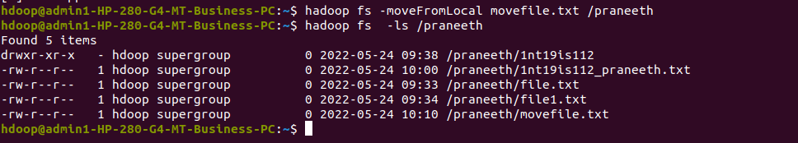

move command
hadoop fs -mv /praneeth/a.txt /praneeth/1nt19is112
hadoop fs -ls praneeth1nt19is112
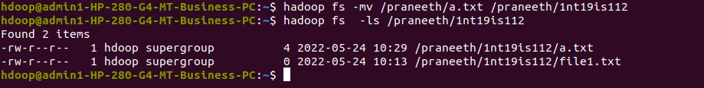

▸ Experiment of cp command
hadoop fs -cp /praneeth/file1.txt /praneeth/1nt19is112
hadoop fs -ls /praneeth/1nt19is112

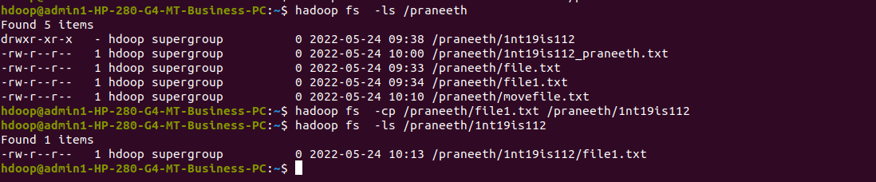

► Display the total size of all the files in name directory
hadoop fs -du /praneeth
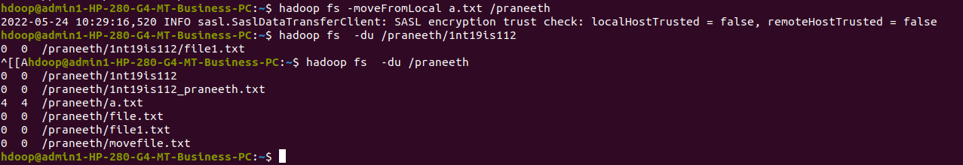
hadoop fs -du -s /praneeth

► Display each file size in usn directory Use stat command on name and usn directories
hadoop fs -stat /praneeth
hadoop fs -stat /praneeth/1nt19is112
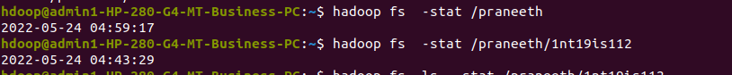

hadoop fs -stat "%b" /praneeth
hadoop fs -stat "%b" /praneeth/1nt19is112

➤ Illustrate the use of append command
hadoop fs -appendToFile b.txt /praneeth/1nt19is112/file1.txt
hadoop fs -cat /praneeth/1nt19is112/file1.txt

